
Difficult conversations workbook
Elizabeth Garrett Anderson Programme

Preparing for difficult conversations
Introduction
At times, in our leadership and management role, we need to have conversations that we would rather not have. This may be to tell someone some bad news, to make or seek an apology, to address an issue about behaviour or conduct, or for a range of other reasons.
This workbook builds on some of the work done during the first Residential Workshop. It aims to help you develop a confident, insightful approach to making difficult conversations as effective as possible. As with any skill, practice helps to refine our approach, and the skill set we are developing here is not one that can be learnt through passive learning. Applying your learning is key to finding out what works for you, so you are encouraged to put what you learn into practice as soon as possible, in order to develop and enhance your skills over time.
The frameworks and tips in this workbook can be used alongside the coaching tool and the meta-mirror technique, which are both part of this topic.

Vital conversations
Alec Grimsley, based in Dorset, is a writer and specialist in the art of having what he refers to as ‘vital conversations’. When faced with a tricky conversation, he identifies that we tend to adopt one of several mindsets, which then affects our whole approach and, to some extent, determines the outcome of the conversation before it has even started.

1st generation thinking
Characterised by our basic human ‘fight or flight’ instinct when faced with something we don’t like. We either resolve to fight it, becoming adversarial and potentially aggressive in our approach, or we decide to flee in order to escape from or avoid the discomfort involved.
There is a strong case suggesting that both these approaches are unsophisticated ways of enacting a leadership or management role, with different, but equally unhelpful, consequences.
For example, the ‘fight’ approach would usually involve the use of power, with the person in this mode using whatever resources they can muster against another person. At its extreme, this may include overt or veiled threats, intimidation, unilateral decision-making, guilt or emotional manipulation. Short-term results of such an approach may be evident; however, the long-term damage to relationships, reputation, respect, trust and credibility will have far more negative impact than any short-term gains.
The ‘flight’ approach typically involves submitting to another person, compromising on what is important, reluctant compliance, a passive approach and avoidance of crucial issues. In the short-term, it may appear to keep the peace; however, in the long-term, it leads to frustration, resentment, a lack of ease and authenticity and non-resolution of important issues.

2nd generation thinking
Essentially based on the knowledge that neither ‘fight’ nor ‘flight’ are socially or politically acceptable ways of dealing with conflict in the workplace. A 2nd generation mindset would be, “I know what I want from this conversation, I have the full picture and I know what needs to be done. But I can’t make this obvious; I need to be seen to listen and then I can do what is needed to get my own way without this being too apparent.”
This approach is an attempt to manipulate a conversation so that it seems that someone is entering into dialogue, when they are in fact motivated by getting their own way, and just not being upfront about it. It is characterised – often unconsciously – by a lack of transparency and honesty, possibly withholding information to retain power and control, and the use of techniques which may appear more sophisticated than merely ‘fighting’ but which, in essence, are just as self-serving.
3rd generation thinking
Involves genuine curiosity in entering a conversation. Through most of our education and much of our professional development, we are conditioned to value being ‘right’. However, wanting to be ‘right’ is often a real problem in having effective conversations about difficult issues because it means our mind is closed to new possibilities. To adopt the 3rd generation mindset, it is important to let go of being right and needing to win and, instead, assume a state of curiosity to understand others’ perspectives and new options.

Capture!
Which style do you usually adopt when entering into a difficult conversation? Does it depend on the circumstances?

3rd generation thinking
The 3rd generation thinking approach is summed up in the table below, drawing on Alex Grimsley’s work.
7 Cs | Underlying assumptions | Strategies/skills/behaviours
Control (self) | My self-awareness and emotional state management have a major impact on my important conversations. | Develop ways of dealing with your emotional state and constantly refine your self-awareness skills.
Clarity | I am clear why I am having this conversation. | Qualify thinking and motives before engaging in an important conversation.  Communicate all necessary information. Use clear examples and get a shared understanding of what important words and concepts mean.
Compassion | The other person is communicating at their best; if they knew better, they would do better.  It is OK for me and the other party to have strong feelings.  I accept that I will make mistakes in important conversations and that’s part of my learning journey. | Respectfully enquire into other people’s motives and reasoning, rather than only judging external behaviour or decisions.  Develop the capability to label and talk about strong emotions, both mine and theirs.  Use a learning journal to turn mistakes and challenging moments into opportunities for growth.
Curiosity | I bng some information to this conversation; others may have different information.  Each person is likely to see things that the other does not or may have missed.  Differences are opportunities for understanding and learning. | Test my and others’ assumptions.  Make my thinking transparent, including sharing my reasoning and motives.  Enquire into others’ different views, feelings and needs.
Courage | I have the right to communicate my ideas, needs, feelings and point of view.  My own thinking may be incorrect and should be challenged.  I have the right to enquire into and compassionately challenge another’s point of view. | Share feelings and make clear requests about my needs and goals where appropriate.  Interrogate my own view of reality and encourage others to challenge my thinking.  Develop enquiry and listening skills.
Collaboration | I strive to meet both parties’ interests/needs wherever possible. | Focus on people’s interests first and create options and solutions second.
Commitment | Both parties are accountable for their commitments and promises. | Seek clarity and accountability on agreements, next steps, actions and timelines.

Capture!
Which aspects of the 7 Cs stood out as areas you feel you need to develop?

Three types of difficult conversation
- The “what happened?” conversation
Arguing doesn’t help
- Don’t argue about whose versions of events is right; explore each other’s stories.
- We think they are the problem; they think we are the problem.
- We each make sense in our story of what happened.
- Arguing blocks us from exploring each other’s stories.
- We each see the world differently:
  - We have different information.
  - We have different interpretations.
  - Our conclusions reflect self-interest.
- Move from certainty to curiosity; embrace both stories.

Don’t assume bad intent
- If people are accused (directly or indirectly) of bad intent, the conversation is not likely to go well.
- Accusations lead to defensiveness and can become self-fulfilling.
- Disentangle intent from impact - if someone has a bad impact on us, we tend to assume this was their intention. We are quite often wrong about this.
- We treat ourselves more charitably; if we jump an amber light, it is OK because we were in a rush; if someone else does, it is because they are a careless driver!
- Good intentions do not excuse bad impact.

Abandon blame
- Almost all situations are the result of the contribution system.
- Blame is about judging and looks backward.
- Contribution is about understanding and looks forward.
- Contributions to a problem may include: avoiding until now; being unapproachable; conflicting assumptions; problematic role assumptions.

2. The “feelings” conversation
Feelings matter
- They are often at the heart of difficult conversations.
- Unexpressed feelings can leak into a conversation, for example through tone, choice of words, body language.
- Unexpressed feelings make it difficult to listen.
- Unexpressed feelings take a toll on our self-esteem and our relationships.

Find your feelings
- Accept that feelings are normal and natural, especially where difficult issues are concerned.
- Good people do have bad feelings.
- Your feelings are as important as theirs.
- Find the feelings lurking under attributions, judgements and accusations
- Use the urge to blame as a clue to find important feelings.

Dealing with feelings
- Don’t treat feelings as gospel: choose which to respond to.
- Be prepared for bad reactions. Difficult conversations can be highly emotional. You can't control how the person will react, be it tears or shouting, but you can be emotionally prepared for it.
- Don’t vent and rant: describe feelings carefully.
- Frame feelings back into the problem – how are they relevant?
- Express the full spectrum of your feelings.
- Don’t evaluate and try to sense-make, just share what you feel.
- Say “I feel … (angry, frustrated, let down, afraid, anxious).” and if this isn’t easy to do, practise it!
- Acknowledge the feelings of others.
- Be aware of the emotional energy in the room and be ready to respond to it.

3. The “identity” conversation
Identity quake
Difficult conversations threaten our identity, raising questions in our mind such as:
- Am I competent?
- Am I a good person?
- Am I worthy of love?
- An identity quake can knock us off balance.

Dealing with an identity quake
- It is not “all or nothing”; don’t deny feedback you receive but consider it carefully so that it doesn’t define who you are.
- Become aware of your identity issues. What do you feel insecure about?
- Acknowledge that your identity may involve apparently contradictory aspects. Don’t over-simplify. Adopt the ‘and’ stance, e.g. ‘I am professional and I make mistakes and I feel proud of my work’.
Accept that:
- You will make mistakes.
- Your intentions are complex.
- You will have contributed to the problem.
- During the conversation, learn to regain your balance.

Preventing an identity quake
Let go of trying to control the other person’s reaction.
- Prepare for their response – anticipate the possibilities as far as you can.

Capture!
Which of these styles do you naturally adopt? Why do you think that is? Is there another approach you think might achieve better effects?

A mediation approach

A shift to support effective dialogue
- Begin from the third story: capture the difference.
- Extend an invitation to talk.
- Their story, your story, third story.
- Explore where each story comes from.
- Share the impact on you.
- Take responsibility for your contribution.
- Describe feelings.
- Consider the possible identity issues.

Even though you may be directly involved in a difficult conversation, it is possible to assume a mindset and approach which takes a 3rd party perspective during the dialogue. This means summarising at points during the conversation the two different sides of the story, and re-framing it as the 3rd story, which acknowledges what each person has shared and balances these.
This approach can take courage, compassion, effort and practice. It can help to enable a more detached analysis of the situation and facilitate a mediated agreement.

Another approach is to shift your thinking from the left to the right of this model.

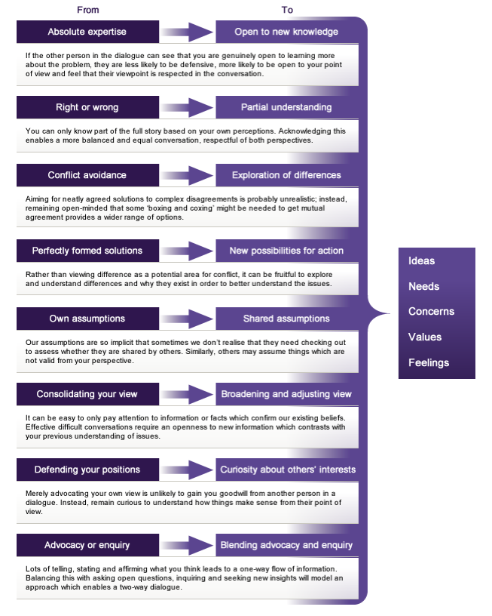
Follow the sequence
- Inquiry – try to learn as much as you can about the other person and their point of view. What do they really want? What are they not saying?
- Acknowledgement – show you’ve heard and understood, paraphrase and explain back.
- Advocacy – once you’ve heard everything they have to offer, clarify your position without attacking theirs.
- Problem solving – try to find solutions. You may need to go back to Step 1.

Actions
Invite joint work
Dialogue is not a solo endeavour. What can we do together to work on this?
Set realistic goals
Make sure the goals you set as a result of the conversation are realistic. This is about achievable change.
Make a record of the planned change
This will give both of you visibility over what needs to be done, and help ensure it happens.
Agree outcomes
Don't dictate what the outcome of the meeting should be. It’s the other person who will have to go away and act on those goals or objectives. If they don’t believe in those outcomes, they’re unlikely to happen.

Top tips
Each of the approaches in this document should give you some interesting things to consider when involved in difficult conversations. Whichever approach you choose to take, below are some general tips that you might find helpful.
Planning the conversation
Rehearse
Rehearse the conversation. Anticipate the difficult questions and prepare suitable answers. You'll dramatically improve the chances of a successful outcome.
Identify the purpose(s) of the conversation
Don't intervene unnecessarily. You should enter the conversation with a supportive purpose in mind. The entire conversation should be aimed at achieving that purpose.
Check out your purposes and decide whether to raise the issue.
Three purposes that work are:
To learn their story (by listening)
To express your views and feelings (by clear expression)
To take part in problem-solving together (by coming to agreed action).
Other purposes are likely to be less successful. Remember, you can’t change other people.
Step into their shoes
You know how you see things, but how does the other person see it? Most difficult conversations are the result of a difference in perceptions, so step into their shoes, and try and see through their eyes.
Take responsibility
You're here because it's your role to help the other person. If it needs attention, don't delay. Act now.

Understanding
Know when to stop
Ask yourself, “Why am I talking?” If you're not adding to the conversation, stop.
Paraphrase to confirm understanding
Listen to what they say. Paraphrase back to them where it will help ensure that both of you understand one another.
Keep focused on the purpose
There's one reason you're there - achieving the purpose. Stick to it. Don't drift off track.
Don't assume that everyone can see your point of view
It's easy to fall into the trap that everyone sees the world as you do. Ensure you explain what you're thinking.

Conversation management
Give bad news upfront
Start with the hard messages(s). Say them in a simple and clear way; you need to make it clear why you're there.
Use ‘and’, rather than ‘but’
‘But’ indicates judgement. Replace it with ‘and’, to avoid objections and blame.
Apologise if appropriate to the situation
Did you contribute to the problem? If so, say what you did and apologise for it if appropriate. Do not apologise unnecessarily; taking responsibility for what you haven’t done will not benefit either of you.

Don't rush
Give yourselves time to gather your thoughts. Give yourself time to obtain more information. Ultimately, give the conversation the time it needs to achieve the purpose.
Create a safe environment
Be clear and positive, both in what you say and how you act. Make it clear from the start that this is about having an open, honest conversation with the aim of a positive outcome.
Don't interrupt
You may miss something important, and you'll discourage the other person. Wait until they've finished, then return to what needs to be addressed. Take notes if necessary to make sure you don't miss anything.
Seek understanding
To make change happen, you need to understand the situation first. Your aim is to understand the other person. Only then can you affect positive change.
Be honest
Being honest invites honesty from others.
Listen, listen, listen.
You can't understand without listening. It transforms the conversation.
Be fully engaged with what the other person is saying. Maintain eye contact. Paraphrase. Nod to show understanding.
Know your boundaries
What's unacceptable? Equally, know their boundaries. Don't cross them. Remain professional and sensitive.

References
Harvard Law School (2008) The New Conflict Management: Strategies for Dealing with Tough Topics & Interpersonal Conflicts Program on Negotiation, Harvard: Harvard Negotiation Project.
Heen, S., Patton, B. and Stone, D. (2000). Difficult Conversations: How to Discuss What Matters Most. Harvard: Penguin. pp. 1-272.
Grimsley, A (2010) Vital Conversations - Making the Impossible Conversation Possible. Princes Risborough/GB: Barnes Holland Publishing Ltd. pp.1-258.

Additional resource:
Peters, S. (2012). The Chimp Paradox. London: Vermillion.

email: care@leadershipacademy.nhs.uk
web: www.leadershipacademy.nhs.uk

